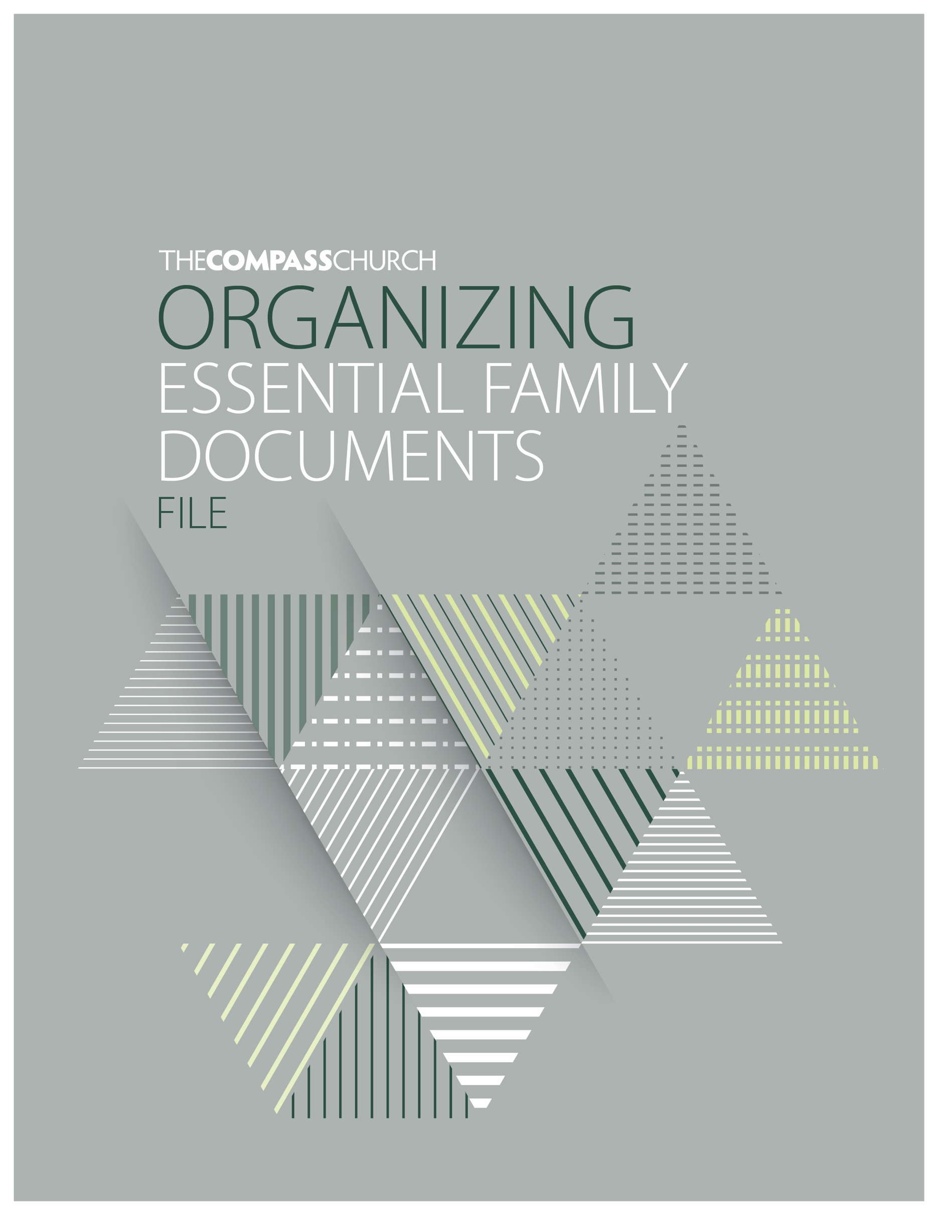

Welcome

Be encouraged!
Investing a small amount of time in organizing your essential family documents file is a wise action step of caring for your loved ones.

Here's how to get started with this resource tool
- Read through the Table of Contents and briefly scan through the complete file to become familiar with this resource tool.
- Make a list of the supporting documents and information you will need to complete this document file. The categories and details are just suggested typical items. Add, omit, or delete any item you find unnecessary.
- Set aside approximately 3-8 hours to complete depending on the complexity of your circumstances. Important things take time. Future updates will be much easier.
- Be prepared to take pictures or scan in copies of key documents using your phone on another device capable of scanning.
- Once completed, choose a location to keep this file that is secure, known and accessible to your spouse, family, and the executor of your Estate.
- Be aware that this does not replace any legal documents, like wills, trusts, or powers of attorney. The actual signed legal documents are necessary to carry out your desires.
- Update this file regularly. It would be wise to revisit this document annually to make sure that it is up-to-date with any changes. Set a date on the calendar as a reminder to revisit and review this document file.
So let's get started.
Honored and Thrilled to be Helping People Find & Follow God with you,
Eric Liechty Pastor of Stewardship
The Compass Church

YOUR FAMILY NAME HERE

DATE OF LAST UPDATE:
TABLE OF CONTENTS
WELCOME
Here’s how to get started with this resource tool
NAME
Name and Date this document
TABLE OF CONTENTS
See the overview of this document
About
Personal and family information. Contact details for spouse, children, grandchildren, great grandchildren, siblings, close friends, etc.
Babysitter
Information and instructions
Executors
Primary and secondary executors of affairs and estate
Legal
Wills, Powers of Attorney for Finances and Healthcare, Trusts, etc.
Financial
Names and contact information of professionals with whom you work, bank, social security, brokerage, retirement (IRA, 401k, 403b, 457, TSP, HSA’s, etc.), pension, annuity, credit card(s), loan(s), bill or subscription payment information, etc.
Medical
Primary care doctor, dentist, specialist, medical insurance, medicare, medicare supplements or advantage plans, medical history, current medications, allergies, authorization to release medical information, Living Will, or Power of Attorney for Healthcare, DNR authorization, etc.
Insurance
Medical, life, vehicle, home, liability umbrella, etc.
Ownership
Home, vehicle, business, storage facility, other real estate, home safes, safe deposit boxes, titles, mortgages, loans, other important possessions, etc.
Tax Returns
Provide your accountant’s or tax preparation software information, Copy of most recent years, etc.
Marriage
Marriage license, divorce papers, etc.
End of Life
Obituary form, recollections & learnings, ten best things list, preference for burial or cremation, preferences or Instructions for your memorial or celebration of life service
Digital
Password management, email accounts, devices, social media accounts, gaming, software, login information, instructions, etc.
Location of Documents
Locations where your digital and physical documents reside
Optional Digital Storage Resource Services
Everplans, Ramsey Vault, 1Password, Secure Cloud Storage Options, etc.
Limitations of this File
TO BE CLEAR
This organizing essential family documents file and all associated materials are intended to inspire and assist you with faithful stewardship information and instruction. This resource is not an attempt to render or replace legal, accounting, or other professional services. Your personal financial situation is unique and fact-dependent. Before making any decisions or implementing any resources, you should consider obtaining information and advice from wise professionals who are fully aware of your circumstances.
About
NOTE: Fill-in the people and information you feel will be most helpful for your loved ones. These are just suggested types of people and information to consider. Delete or add additional people and categories as you feel would be most helpful.
You
Name, Phone, Email, Address, Date of Birth, Social Security Number, etc.
Spouse
Name, Phone, Email, Address, Date of Birth, Social Security Number, etc.
IDs and Vital Documentation
Social security number(s), birth certificate(s), driver’s license, immigration documentation, marriage license, passport(s), death certificate, etc.
Employer(s)
Name(s), Phone, Email, Address, Website, etc.
Church
Church Name, Phone, Email, Address, Website, etc.
Degrees and Certifications
Name of School, Name of Degree or Certification, Date of Graduation, Honors or Awards, Phone, Email, Address, Website, etc.
Military Service
Branch of Service, Rank, Awards or Medals, Discharge Date, DD214 Release Form, Website, etc.
Clubs and Affiliations
Name, Phone, Email, Address, Website, etc.
Miscellaneous
Name, Phone, Email, Address, Website, etc.
Child(ren)
Name(s), Phone, Email, Address, Date of Birth, Social Security Number, etc.
Grandchild(ren)
Name(s), Phone, Email, Address, Date of Birth, Social Security Number, etc.
Great Grandchild(ren)
Name(s), Phone, Email, Address, Date of Birth, Social Security Number, etc.

Sibling(s)
Name(s), Phone, Email, Address, Date of Birth, Social Security Number, etc.
Close Friend(s)
Name(s), Phone, Email, Address, Date of Birth, Social Security Number, etc.

Babysitter
Try to keep to one (1) page of information and instructions.
Call 911 - In case of serious emergency.
Parent Phone Number(s)
Name, Phone
Spouse Name, Phone
Nearest Preferred Hospital
Name, Phone, Address
Primary or Pediatric Physician(s)
Name, Phone, Address
Additional Close Family or Friend(s) Contact Information
Name, Relationship, Phone, Note
Instructional Notes
Clothing, Meals, Bedtime, Activities, Expectations, Other helpful information, etc.

Executors
OF AFFAIRS AND ESTATE

You
Name, Phone, Email, Address, Date of Birth, Social Security Number, etc.
Spouse
Name, Phone, Email, Address, Date of Birth, Social Security Number, etc.
Child(ren)
Name(s), Phone, Email, Address, Date of Birth, Social Security Number, etc.
Close Friend(s)
Name(s), Phone, Email, Address, Date of Birth, Social Security Number, etc.

Legal

Wills
Scan in copy of document, Give actual location of document, Any passwords or passcodes, etc.
Power of Attorney for Healthcare
Scan in copy of document, Give actual location of document, Any passwords or passcodes, etc.
Power of Attorney for Finances
Scan in copy of document, Give actual location of document, Any passwords or passcodes, etc.
Trusts
Scan in copy of document, Give actual location of document, Any passwords or passcodes, etc.
FINANCIAL

Financial Advisor
Name, Phone, Email, Address, Website, etc.
Accountant - Tax Professional
Name, Phone, Email, Address, Website, etc.
Attorney - Estate Planning
Name, Phone, Email, Address, Website, etc.
Personal Banker
Name, Phone, Email, Address, Website, etc.
Other Financial Professional
Name, Phone, Email, Address, Website, etc.
Financial Accounts & Balances
ACCOUNTS | CURRENT BALANCE | PERCENTAGE OF TOTAL | AS OF DATE | NOTES
BANK ACCOUNTS | $1.11 | 10.00% | 8/29/2022 | These are just notes for details.
BROKERAGE INVESTMENT ACCOUNTS | $2.22 | 20.00% | 8/29/2023 | These are just notes for details.
RETIREMENT ACCOUNTS (IRA/401K/403B/ETC.) | $3.33 | 30.00% | 8/29/2024 | These are just notes for details.
ADD ADDITIONAL ACCOUNTS AS NEEDED | $4.44 | 40.00% | 8/29/2025 | These are just notes for details.
TOTALS | $11.10 | 100%

Bank ACCOUNTS
This information helps your loved ones know where your cash is located. Provide information about your checking accounts, savings accounts, certificates of deposits, or other cash accounts.
Financial Institution Name, Account Owner, Website, Phone,
Username, Password, 2-Step Authentication, Security Question/Answer,
Account Type - Account Number
Debit Card(s) Associated with this Cash Account Y/N?
Debit PIN
Notes
Repeat for each additional Account
SOCIAL SECURITY
For those who are receiving Social Security.
Full Name, Social Security Number, Website, Phone,
Are they SS eligible and qualified?
Username, Password, 2-Step Authentication, Security Question/Answer
Notes
Spouse Full Name, Social Security Number, Website, Phone,
Username, Password, 2-Step Authentication, Security Question/Answer
Are they SS eligible and qualified?
Notes
Brokerage, INVESTMENT, & RETIREMENT Accounts
Provide all investment and retirement account information. This may include 401(k)s, 403(b)s, TSPs, Traditional IRAs, Roth IRAs, Simple IRAs, Solo 401(k)s or college savings plans, Health Savings Accounts (HSAs).
Brokerage Investment Accounts
Financial Institution, Account Owners, Website, Phone
Username, Password, 2-Step Authentication, Security Question/Answer,
Account Name(s)
Primary Beneficiary
Secondary Beneficiary
Financial App Name
Username, Password, 2-Step Authentication, Security Question/Answer,
Notes
Repeat for each additional Account
Retirement Investment Accounts
Financial Institution, Account Owner, Website, Phone
Username, Password, 2-Step Authentication, Security Question/Answer,
Account Name, Account Type (IRA, 401k, 403b, 457, TSP, etc.), Traditional or Roth?
Primary Beneficiary
Secondary Beneficiary
Financial App Name
Username, Password, 2-Step Authentication, Security Question/Answer,
Notes
Repeat for each additional Account
Pension Accounts
Custodian, Account Owner, Website, Phone
Username, Password, 2-Step Authentication, Security Question/Answer,
Payment Schedule, Payment Amount, Terms, etc.
Primary Beneficiary
Secondary Beneficiary
Financial App Name
Username, Password, 2-Step Authentication, Security Question/Answer,
Notes
Repeat for each additional Account
Annuity Accounts
Custodian, Account Owner, Website, Phone
Username, Password, 2-Step Authentication, Security Question/Answer,
Payment Schedule, Payment Amount, Terms, etc.
Primary Beneficiary
Secondary Beneficiary
Financial App Name
Username, Password, 2-Step Authentication, Security Question/Answer,
Notes
Repeat for each additional Account

CREDIT CARD INFORMATION
Provide information on your credit card accounts.
Total Number of Credit Cards =
Financial Institution, Account Owners, Website, Phone
Username, Password, 2-Step Authentication, Security Question/Answer,
Card Name, Account Number, PIN, Monthly Day When Payment is Due
Notes
Repeat for each additional Account
LOAN INFORMATION
This is the place for you to provide all loan information, including mortgages, home equity lines of credit (HELOCs), car loans, boat loans, student loans, personal loans, and other financed items. Include any owed money, other than credit card debt.
Loan Information
Debt Type, Debt Holder, Website, Phone,
Username, Password, 2-Step Authentication, Security Question/Answer,
Loan Balance as of this date, Monthly Payment Amount, Monthly Payment Day of Month Due
Notes
Repeat for each additional Account

BILL OR SUBSCRIPTION PAYMENT INFORMATION
Review your past year’s statements so you do not miss quarterly, semi-annual, and annual bill payments. Provide all bill payment information, including rent, utilities, subscription services, internet, and phone bills.
Bill or Subscription Payment
ACCOUNT SERVICES & SUBSCRIPTIONS | DESCRIPTION OF PAYMENT ACCOUNT USED | FREQUENCY - ANNUALLY, QUARTERLY, MONTHLY, AS NEEDED | AMOUNT | ANNUAL TOTAL | NOTES
1Password | Citi MasterCard | Annually | $60.00 | $60.00 | Password Manager for All Digital Devices
Ally Savings | Transfer to Fidelity Account | Monthly |  |  | Investing $500 per month
Amazon | Citi MasterCard | As Needed | $0.00 | $0.00
City of St. Charles | Citi MasterCard | Monthly | $180.00 | $2,160.00 | Electric, Water, Sewer, YardWaste
I-Pass / EZ-Pass | Citi MasterCard | As Needed |  | $350.00 | Transponder Replenished in $20
Intuit - TurboTax | Citi MasterCard | Annually | $110.00 | $110.00 | November Tax Software
LRS - Lakeshore Recycling Service | Citi MasterCard | Quarterly | $65.00 | $260.00 | Trash and Recycling Service
Metronet | Chase Bank Account | Monthly | $70.00 | $840.00 | Fiber Internet Service at 500 mbps
Planet Fitness | Chase Bank Account | Monthly | $30.00 | $360.00 | Gym
Sleep Cycle | Citi MasterCard | Annually | $8.99 | $8.99 | Sleep Tracking App
Starbucks | Citi MasterCard | As Needed |  |  | Replenished as needed at $50 per replenish
YouTube TV | Citi MasterCard | Monthly | $65.00 | $780.00 | TV Channels including local and unlimited DVR
TOTAL |  |  |  | $4,928.99

Bill or Subscription Type, Company, Website,
Username, Password, 2-Step Authentication, Security Question/Answer,
Frequency, Automatic Payment Yes or No?
Monthly Payment Day of Month Due
Notes
Repeat for each additional Account
Medical

Medical Primary Care Physician(s)
Name(s), Phone, Email, Address, Website, etc.
Dentist(s)
Name(s), Phone, Email, Address, Website, etc.
Optometrist(s)
Name(s), Phone, Email, Address, Website, etc.
Specialist(s)
Name(s), Phone, Email, Address, Website, etc.
Medical Insurance Provider(s)
Name(s), Phone, Email, Address, Website, etc.
Medicare
Name(s), Phone, Email, Address, Website, etc.
Notes
Medicare Supplements or Advantage Plan(s)
Name(s), Phone, Email, Address, Website, etc.
Notes
Medical History
Provide any helpful family or personal medical history or notes. If applicable, include spouse medical history.
Current Medication(s)
Name of medication, dosage, how often, etc.
KnowN Allergies or reactions to medication
Notes
Authorization to Release Medical Information
Scan in authorization.
Living Will or Power of attorney for Healthcare Decisions
Scan in authorization.
DNR Authorization
Scan in authorization.
Insurance

INSURANCE INFORMATION
Provide all insurance information, including: medical, life, vehicle, home, liability umbrella, etc.

Medical Insurance Provider(s)
Name(s), policy number, phone, email, address, website, notes, etc.
Disability Insurance Provider(s)
Name(s), policy number, phone, email, address, website, notes, etc.
Life Insurance Provider(s)
Name(s), policy number, phone, email, address, website, notes, etc.
Vehicle Insurance Provider(s)
Name(s), policy number, phone, email, address, website, notes, etc.
Home Insurance Provider(s)
Name(s), policy number, phone, email, address, website, notes, etc.
Liability Umbrella Insurance Provider(s)
Name(s), policy number, phone, email, address, website, notes, etc.
Other Insurance Provider(s)
Name(s), policy number, phone, email, address, website, notes, etc.

Ownership

Ownership INFORMATION
Provide all home, vehicle, business, storage facility, other real estate, home safes, safe deposit boxes, titles, mortgages, loans, other important possessions, etc.

Home
Address, Parcel Number, Title, Notes, Repeat for any additional, etc.
Vehicle
Make, Model, Year, VIN Number, Title, Notes, Repeat for any additional, etc.
Business
Name, Address, LLC Number, Any Partners, Most recent audited financial books, Notes, Repeat for any additional, etc.
Storage Facility
Name, Address, Unit Number, List of items, Notes, Repeat for any additional, etc.
Other Real Estate
Land location, Address, Parcel Number, Title, Notes, Repeat for any additional, etc.
Home Safe
Location, Combination or Key Location, Notes, Repeat for any additional, etc.
Safe Deposit Box
Location, Combination or Key Location, Notes, Repeat for any additional, etc.
Titles
Scans of actual titles of homes, vehicles, etc., Repeat for any additional, etc.
Other important possessions information
Name of possession, Details regarding mortgages, loans, titles, Other information, Repeat for any additional etc.

Tax Returns

TAX INFORMATION
Provide your accountant’s or tax preparation software information. Include a copy of your most recent year or two years’ basic tax returns following this page. If you are creating a digital file, save the documents as a PDF and insert them into this file or provide a location and link.

Accountant - Tax Professional
Name, Phone, Email, Address, Website, etc.
Tax Preparation Software
Tax Preparation Software Name, Account Owner, Website, Phone,
Username, Password, 2-Step Authentication, Security Question/Answer,
Account Type - Account Number
Any Credit or Debit Card(s) Associated with this software as a subscription?
Any PIN?
Notes

Marriage

Marriage INFORMATION
Provide your marriage license, divorce papers, etc.

Marriage
Names, Date, Location, Scanned-in copy of Marriage License, Notes, Repeat for any additional, etc.
Divorce
Date, Location, Scanned-in copy of Divorce Papers, Notes, Repeat for any additional, etc.

End of Life

End of life INFORMATION
Provide your obituary information, recollections & learnings, ten best things list, preference for burial or cremation, preferences or instructions for your memorial or celebration of life service.

Obituary
Put typical obituary information here. Name. Date and place of birth. Date and place of death. Circumstances of death if desired. Schools attended, degrees or certifications received. Military service and awards. Religious or church affiliation. Career information of jobs held. Names of close family members surviving and pre-deceased including: parents, siblings, spouse, children, stepchildren, grand children, great-grand children, etc. Life passions, service, and impact achievements. Visitation and service times and locations. Where memorial gifts can be given.
Recollections & Learnings
Share some of your best memories and learnings of your lifetime.
Ten Best Things List
What is your list of the ten best things in life?
Burial or Cremation Preferences
What is your preference for burial or cremation?
Memorial or Celebration of Life Service Preferences
What are your desires for your memorial or celebration of life service?
GRAVE LOCATION PREFERENCE
City, State, Location, or none desired, etc.
Headstone epitaph PREFERENCE
Design type, Words or Scripture, or none desired, etc.
Notes to loved Ones
Record any notes you would like shared with loved ones. If a video note, share location or link and password.

Digital

Digital INFORMATION
Password management, email accounts, devices, social media accounts, gaming, software, login information, instructions, etc..

Password Management
Name of Software or Location of Passwords, Account Owner, Website, Phone
Username, Password, 2-Step Authentication, Security Question/Answer,
Notes
Repeat for each additional Account
Email account(s)
Total number of email accounts
List in order of use and importance
Email Address Name abc@, Account Owner, Website,
Username, Password, 2-Step Authentication, Security Question/Answer,
Notes
Repeat for each additional Account
Digital Devices
Total number of computers, tablets, phones, watches, etc.
List in order of use and importance
Name of item, Serial Number, Primary Use
Username, Password, 2-Step Authentication, Security Question/Answer,
Notes
Repeat for each additional Account
Social Media Account(s)
Total number of accounts
List in order of use and importance
Name of Account, Web Address, Primary Use, Do you want this account deleted, memorialized, or other?
Username, Password, 2-Step Authentication, Security Question/Answer,
Notes
Repeat for each additional Account

Gaming Account(s)
Total number of accounts
List in order of use and importance
Name of Account, Web Address, Primary Use, Do you want this account deleted, memorialized, or other?
Username, Password, 2-Step Authentication, Security Question/Answer,
Notes
Repeat for each additional Account

Software Account(s)
Total number of accounts
List in order of use and importance
Name of Account, Web Address, Primary Use, Do you want this account deleted, memorialized, or other?
Username, Password, 2-Step Authentication, Security Question/Answer,
Notes
Repeat for each additional Account

Location of DocumentS

Location of Documents INFORMATION
Locations where your digital and physical documents reside.

LOCATION OF DOCUMENTS
Location of where essential physical documents are located i.e. wills, powers of attorney, trusts, titles, deeds, etc.
List in order of use and importance
Name the documents and where they can be found.
Username, Password, 2-Step Authentication, Security Question/Answer, Key, or Passcode, etc.
Notes
Repeat for each additional Account

Optional digital storage resource serviceS

Everplans
Everplans is a simple and secure digital storage subscription service designed specifically for storing important documents. You can review this service at: https://www.everplans.com
RAMSEY VAULT
A digital way to organize and protect your most important information all in one place.
https://www.ramseysolutions.com/store/digital-products/ramsey-vault
1Password
1Password is primarily a digital password storage service. However, they do have an area where you can keep some secure notes. You can review this service at: https://1password.com
Save Your Document Encrypted on A Secure Cloud Server
There are secure ways to save your file on popular services like Apple iCloud, Google Drive, Microsoft OneDrive, Dropbox, etc. Just do your research and take the steps to password protect your Essential Family Documents File. You will also find it helpful and insightful to discuss the most current secure, and simple ways with your loved ones to see their recommendations, and preferences for gaining access to this important information.
– 25
Optional digital storage resource serviceS

Everplans
Everplans is a simple and secure digital storage subscription service designed specifically for storing important documents. You can review this service at: https://www.everplans.com
RAMSEY VAULT
A digital way to organize and protect your most important information all in one place.
https://www.ramseysolutions.com/store/digital-products/ramsey-vault
1Password
1Password is primarily a digital password storage service. However, they do have an area where you can keep some secure notes. You can review this service at: https://1password.com
Save Your Document Encrypted on A Secure Cloud Server
There are secure ways to save your file on popular services like Apple iCloud, Google Drive, Microsoft OneDrive, Dropbox, etc. Just do your research and take the steps to password protect your Essential Family Documents File. You will also find it helpful and insightful to discuss the most current secure, and simple ways with your loved ones to see their recommendations, and preferences for gaining access to this important information.

